**Week -1: Basics**

1)Python Installation:

Windows:

1. Download Python: Go to the official python website at

|  |
| --- |
| <https://www.python.org/downloads/> |

and click on the “Download Python” button. Choose the latest version for windows.

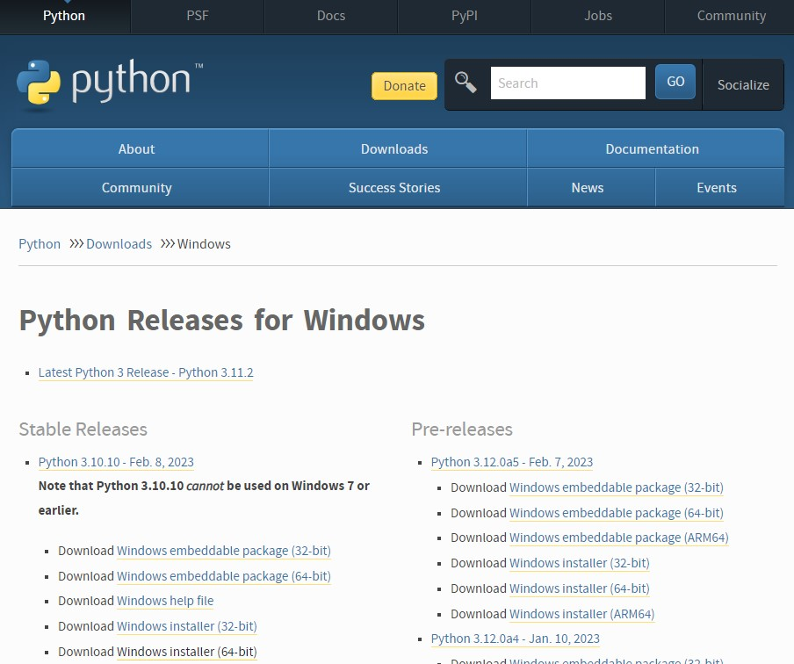

1. Run Installer: Locate the downloaded installer file (usually named something like python-3.10.10.exe) and double-click it to run the installer.

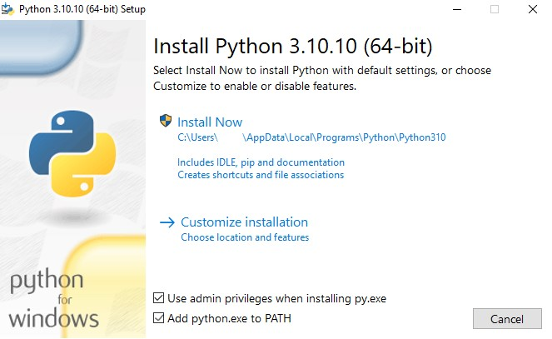

1. Customize Installer (Optional): On the first screen of the installer, make sure to check the box that says “Add Python 3.x to PATH.” This will make it easier to run Python from the Command Prompt. You can also customize the installation directory if needed.

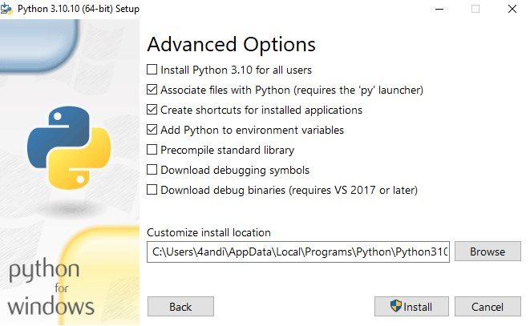

1. Install Python: Click the “Install now” button to start the installation process. The installer will copy the necessary files to your system.
2. Installation complete: Once the installation is complete, you’ll see a screen that says “Setup was successful.” You can now close the installer.

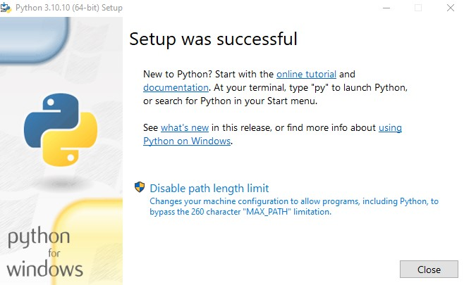

1. **Start a Python interpreter and use it as a Calculator.**

#Calculator

a=int(input("enter a number")) b=int(input("enter a number")) print("add:",a+b) print("sub:",a-b) print("multiplication:",a*b) print("division:",a/b) **Output:**

enter a number 4 enter a number 5 add: 9 sub: -1 multiplication: 20 division: 0.8

1. **Write a program to purposefully raise Indentation Error and correct it.** #Indentation Error a=5

b=2 print("add:",a+b) #correct program a=5 b=2

Print(“add:”,a+b) **Output:**

7

1. **i) Write a program to calculate compound interest when principal, rate and number of periods are given.**

**Program:**

#compound interest

#p=principle,r=rate,t=time period,CI=compound interest,A=amount after time period p=1000 r=2

t=3

A=p*((1+r/100)**t) CI=A-p

print("amount after time period",A) print("compound intrest:",CI) **output:**

amount after time period 1061.208 compound intrest: 61.208000000000084

**ii) Given coordinates (x1, y1), (x2, y2) find the distance between two points Program:**

x1=int(input("enter the x1 value")) x2=int(input("enter the x2 value")) y1=int(input("enter the y1 value")) y2=int(input("enter the y2 value")) d=((x1-x2)**2+(y1-y2)**2)**(1/2) print("distance between two given points is ",d) **output:**

enter the x1 value0 enter the x2 value2 enter the y1 value0 enter the y2 value2

distance between two given points is 2.8284271247461903

**5. Read name, address, email and phone number of a person through keyboard and print the details.**

**Program:**

name=input("enter your name ") email_id=input("enter your email-id :") phone_no=int(input("enter your phone number :")) address=input("enter your address :") print("Name:",name) print("Email-id:",email_id) print("Phone-no:",phone_no) print("Address:",address) **output:**

enter your name :Divya enter your email-id :divya@gmail.com enter your phone number :987654321 enter your address: Hyderabad,Telangana

Name: Divya

Email-id: divya@gmail.com

Phone-no: 987654321

Address: Hyderabad,Telangana